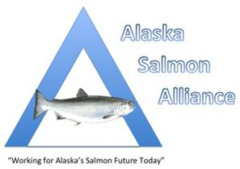

February 13, 2014

CONTACT: Arni Thomson, Exec. Director, (907)929-0388

Statement Issued on Drift-Only Days in the Kenai River

The Alaska Salmon Alliance is releasing the following statement regarding the Board of Fish decision not to designate an additional drift-only day in the Kenai River:

“We are disappointed by this vote,” said Arni Thomson, Executive Director of ASA. “This is a missed opportunity to help ensure the health and security of Kenai River kings by limiting noise and water pollution and preventing damage to habitat and spawning beds.”

###

The Alaska Salmon Alliance (ASA) is a 501(c)6 fisheries trade organization representing seafood processors and commercial fishermen of the Kenai Peninsula. We advocate for a thoughtful, process-oriented allocation of Cook Inlet salmon for the benefit of all Alaskans.

